The Café Terrace at Night

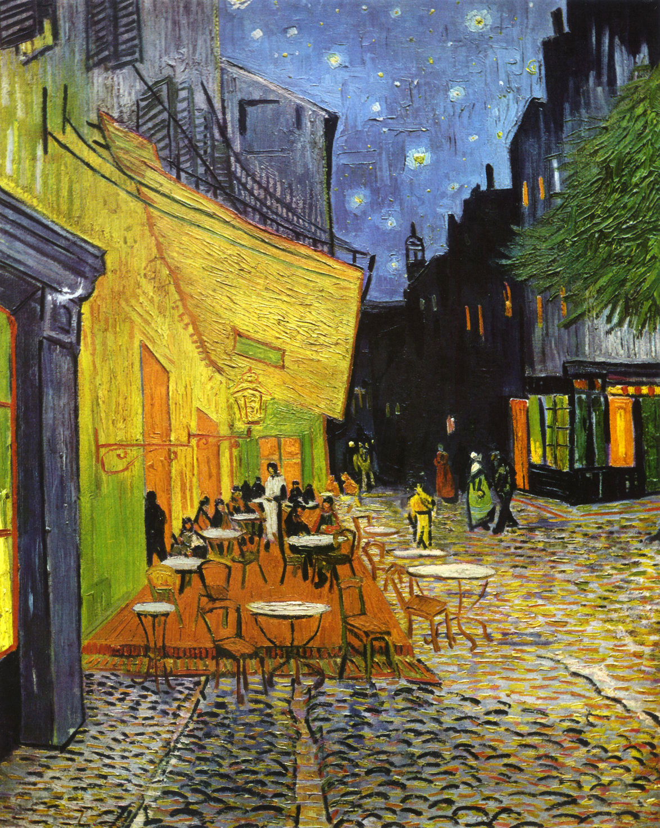

The Café Terrace at Night (Terrasse de Cafe de Nuit) is an oil painting of a café terrace which in Arles, France by the famous (not in his time, unfortunately) Dutch painter, artist Vincent Van Gogh, painted in 1888. It is also known as The Café Terrace on the Place du Forum. This was one of the first scenes Van Gogh painted during in his stay in Arles and the first painting where he used a nocturnal background.[1] “Café Terrace at Night” is one of three Arles paintings that feature Van Gogh’s distincitive star-filled sky. Starry Night Over the Rhone and Starry Night complete the trilogy. [2] Artist used materials which are oil paint colors and tubes and as usual, canvas. The size of the painting has a height of 80.7 cm and a width of 65.3 cm and it is in Kröller-Müller Museum in Otterlo, Netherlands.[3] The street in painting which is in Arles still remains unchanged and the café still exist and it is named Café van Gogh. Also Van Gogh wrote a letter after he painted The Café Terrace at Night about how beatiful nights colors than days.

The Café Terrace at Night (1888), it is an oil painting on canvas showing a beatiful street in France at night with a nice café and a beautiful, tremendous night sky. There is a café, which sheds light on people and the road, which gives us the thought that the nights in Arles is alive. This painting of colorful outdoor view is a picturesque work, the vision of a relaxed spectator who enjoys the charm of his surrounding without any moral concern. It recalls Van Gogh's mood when he wrote, "the night is more alive and more richly colored than the day."[4]

**Art Elements of The Café Terrace at Night**

In The Café Terrrace at Night, the artist uses little and curved lines to paint the roand. He is known for his use of line like this one. He painted caffe’s roof (the upper platform of the building, which is looking like awning) like it is a real one, with real wall patterns. He used vertical and horizontal lines for the left side of the painting. His use of line, texture and vivid colors are almost immediately recognizable. The lines throughout this painting provide variety ; some straight (as in the buildings) and some curved (the cobblestone streets and starry night sky).[5]

In The Café Terrace at Night, the artist uses curving shapes to illustrate the road. The stars are shaped like a doth and ,as I said in previous paragraph, artist used horizontal and vertical shapes for buildings, which is made them look like real, altough this a real view painting. The windows are rectangular, tables are like circles. We can say that this paintings texture and patterns are looking real, it is like painting has its own world, its living. When you look at it so much, there are people sounds, there is a music made by a violing and a breeze coming through you.

In this painting artist used yellow, brown, green, gray and black too much, which gave the painting a cold look. He used black for depth so we can say that he made the night colorful and bright. Also the café is looks welcoming and warm with those colors used. The colors in this painting are bold and vibrant. The high intensity of this painting showcases the bold strokes and bright color palette. Van Gogh himself says, “here you have a night painting without black, with nothing but beautiful blue and violet and green and in this surrounding the illuminated area colors itself sulfur pale yellow and citron green.”[6]

The artist made great use of space. He used a linear perspective, which is three dimensioanal and has a depth. Through to vanishing point atmosphere is going dark and use of black is increasing. He painted people in painting parallel with depth so we can understand which one is where and we can say that thing for other things like road, tables, building and windows. From painters place, main perspective, through vanishing point he made lights and shadows so real. Behind the tree there is a building with lights on it same with the building which has the café. It shows us this part of the street is alive at night and going inside the painting there is nothing but darkness. It makes us think that there is nothing in there but just buildings and a narrow street. He made the balance between light and dark good. Also we can say that this painting is like a picture taken by a camera but it is not moving. Because of that, we can say that there is implied motion in this painting.

**Principles of Design**

Lines have the variety, curved, horizontal, vertical and straight, in the painting. Variety of different lines makes painting more interesting. Also colors have variety, yellow, green, orange, grey, black and blue. But when you look at the painting you mainly see shades of yellow, because of the main thing of the painting: The Café. If we talk about unity of lines or colors we can’t completely say that there is an evident unity. Because there are different lines on café’s walls or on the road. Also if we look at the sky there are at least three kind of lines used by artist.

In this painting we can’t say there is a balance between lines and colors because they are all different from each other but this asymmetry doesn’t make painting less tremendous, on the contrary it does it better in this art. On the café itself, there is a lot of emphasis. We can tell because it is a very bright color, while the rest of this piece takes on a darker, more neutral tone. The cafe is the focal point of the painting and Van Gogh uses color more than anything to represent that. Another way Van Gogh emphasized the cafe is texture. [7] We can saay that the café and the roof is the main thing in this painting. One noticeable thing is how the cafe leans over into the middle of the painting. The bright yellow color attracts the eyes and it seems just a little off balance. However, the elements in the piece do even out nicely.[8]

In the painting, some patterns have a rhythm like those on the road. Curved lines and colors made a pattern, which looks like repeating. In addition, there is a depth in this painting through vanishing point. Artist used this lines and colors to create a nice three-dimensional art.

**Conclusion Remarks and Opinions**

In The Café Terrace at Night, artist uses art elements such as curved, vertical, horizontal and straight lines, different shapes, colors and pattern to create this art. He used curved lines to create patterns on the road and used horizontal, vertical straight lines to paint café walls, which are looking like real. In addition, he used straight lines to paint the tree, buildings and the sky. The artist used yellow to create café and lights perfectly and that made this painting very similar to normal world or moment he painted it, which making us hear street sounds, people voices like we are living in the moment. He made this painting alive by using those colors, lines, perfect depth and perspective.

**Conclusion-Part 2**

In my opinion, Van Gogh uses art elements and principles of art effectively and perfectly. He created objects so smart. For example, he used same yellow to create café walls and lights it creates. When I first notice it, it made me say “Oh this is a clever move”. I love Van Gogh’s art and personality. Not just this painting, all of his other painting are made by his beautiful but complex world and every time I look at his paintings, I just forget the real cruel world, stare at the art forever and jump into his paintings. The same goes for this painting. He used lines perfectly and made them look real. He used the perspective and the depth that makes us we are looking to street from his place. Taking everything in to consideration, the painting is rich in terms of colors, lines, patterns and space.

# **References**

*‘Cafe Terrace at Night’ by Vincent Van Gogh.* April 30, 2019. https://thebuhlercrusader.org/2019/04/30/cafe-terrace-at-night-by-vincent-van-gogh/ (accessed March 15, 2020).

*Café Terrace at Night.* October 17, 2019. https://en.wikipedia.org/wiki/Café_Terrace_at_Night (accessed March 15, 2020).

*Café Terrace at Night, 1888 by Vincent Van Gogh.* n.d. https://www.vincentvangogh.org/cafe-at-night.jsp (accessed March 15, 2020).

Flitcraft, Kelly. *VAN GOGH: Cafe Terrace at Night.* June 26, 2014. https://prezi.com/e_ffodrollk1/van-gogh-cafe-terrace-at-night/ (accessed March 15, 2020).

*Vincent van Gogh Artist Overview and Analysis.* January 21, 2012. https://www.theartstory.org/artist/van-gogh-vincent/artworks/ (accessed March 15, 2020).

1. The information is taken from: https://www.theartstory.org/artist/van-gogh-vincent/artworks/
2. Paintings informations taken from: https://www.vincentvangogh.org/cafe-at-night.jsp
3. Size and museum information is taken from: https://en.wikipedia.org/wiki/Café_Terrace_at_Night
4. Painting information taken from: https://www.vincentvangogh.org/cafe-at-night.jsp
5. Line info taken from: https://prezi.com/e_ffodrollk1/van-gogh-cafe-terrace-at-night/
6. Color information taken from: https://prezi.com/e_ffodrollk1/van-gogh-cafe-terrace-at-night/
7. Info of emphasis taken from: https://www.theartstory.org/artist/van-gogh-vincent/artworks/
8. Proportion information is taken from: https://thebuhlercrusader.org/2019/04/30/cafe-terrace-at-night-by-vincent-van-gogh/